**EXERCISE – UNIT 9 (Grade 6)**

**I. Choose the best answer.**

1. He lifts heavy weights as a sport. He's a _________.

A. Gymnast          B. Engineer         C. Farmer           D. Weight lifter

2. It's a beautiful day. The sky is ________.

A. Black             B. Blue             C. Gray             D. Green

3. ________ her lips full or thin?

A. Are               B. Is               C. Do               D. Does

4. ________ colour are her eyes?

A. Who              B. What            C. How              D. Where

5. He is _______ between his sister and his brother.

A. Sit                B. Sits             C. Siting             D. Sitting

6. She puts her _______ over her ears.

A. Legs              B. Feet            C. Hands            D. Toes

7. _______ does she do? "She's a gymnast"

A. What              B. How             C. Who              D. Which

8. Look! The teacher ________.

A. Come             B. Comes           C. Coming D. Is coming

9. ______ English at the moment?

A. Do you study    B. Are you studying  C. What do you do?    D. How do you do?

10. - ______- That’s Jill, my classmate.

A. What’s that?    B. Who’s that?      C. What are those?     D. Who are they?

11. Susan ______ long hair.

A. not have        B. isn’t have        C. doesn’t have        D. not has

12. ______ a round face?

A. Does she have    B. Is she        C. Is she having         D. Has she

13. – What are _______ ?- They’re strawberries.

A. these          B. there           C. this                 D. that

14. - ______- We go to school early in the morning.

A. When do you go to school?        B. What are you doing?

C. Where are you going?            D. How do you go to school?

15. Maria ______ a lot of pencils.

A. has            B. have            C. is having          D. are having

16. We ______ swimming every day.

A. goes          B. go              C. is going           D. are going

17. _____ her hair long?

A. Does         B. Do          C. Is          D. Are

18. Cindy has ______lips

A. heavy        B. full          C. tall         D. noisy

19. What color ______your shoes?

A. is           B. are          C. does       D. do

20. – How ______ to school every day?- They walk to school every day.

A. are they go     B. do they go     C. often do they go     D. do they walk

**II. Choose a word in column A with its opposite word in column B - Chọn từ ở cột A trái nghĩa với từ ở cột B**

|  |  |
| --- | --- |
| **A** | **B** |
| 1. strong | fat |
| 2. ugly | heavy |
| 3. short- | young |
| 4. old | old |
| 5. new | tall |
| 6. thin | weak |
| 7. light | beautiful |

**II. Match.**

|  |  |  |
| --- | --- | --- |
| **A**  1. What are you doing now?  2. Is your father working in a museum?  3. Does he play tennis after school?  4. Is she a gymnast or a singer?  5. Is his sister’s hair long or short?  6. Are your brothers thin?  7. What color are her sisters’ eyes?  8. What color is his hair? | **B**  A. They’re blue.  B. Yes. It’s long.  C. It’s black.  D. I’m reading books in the library.  E. It’s short.  F. No. They are fat.  G. She is a gymnast.  H. No. He is working in a drugstore.  I. No. He helps his mother with the housework. | **ANSWER**  1. ____  2. ____  3. ____  4. ____  5. ____  6. ____  7. ____  8. ____ |

**IV. Use the correct form of words.**

1. The bag is so ……………………… (heavily)

2. She is a ……………………… (gym)

3. Peter is a weight ……………………… (lift)

4. He is ……………………… (strength)

**V. Read.**

Miss Lee is a teacher. She is tall and thin. Her face is oval. Her hair is long and black. Her eyes are big and brown. Her nose is small. Her lips are red and full. She is beautiful. And she is a good teacher, too.

**Write TRUE or FALSE.**

1. ……………… Miss. Lee is a good teacher.
2. ……………… Miss. Lee has a round face.
3. ……………… Miss. Lee's eyes are big and blue.
4. ……………… Miss. Lee is tall and weak.

**VI. Rewrite the sentence without changing the meaning.**

1) His hair is short. ￫ He has ……………………………………………………………………………….

2) His elder sister’s eyes are brown. ￫ His elder sister has ………………………………………………..

3) Her brother’s nose is big. ￫ Her brother ……………………………………………………………….

4) Their ears are small. ￫ They …………………………………………………………………………….

5) His father’s mouth is wide. ￫ His father ………………………………………………………………..

6) Her lips are thin. ￫ She …………………………………………………………………………………..

7) Her grandmother’s teeth are white. ￫ Her grandmother ……………………………………………….

8) His lips are full. ￫ He has ……………………………………………………………………………….  
9) Mary is beautiful. ￫ Mary is a …………………………………………………………………………..

10) Linda has long black hair. ￫ Linda’s ………………………………………………………………….

**The end**

**UNIT 10: STAYING HEALTHY**

**VOCABULARY**

**I. Write:** a bowl of noodles, bread, a glass of orange juice, a glass of lemonade

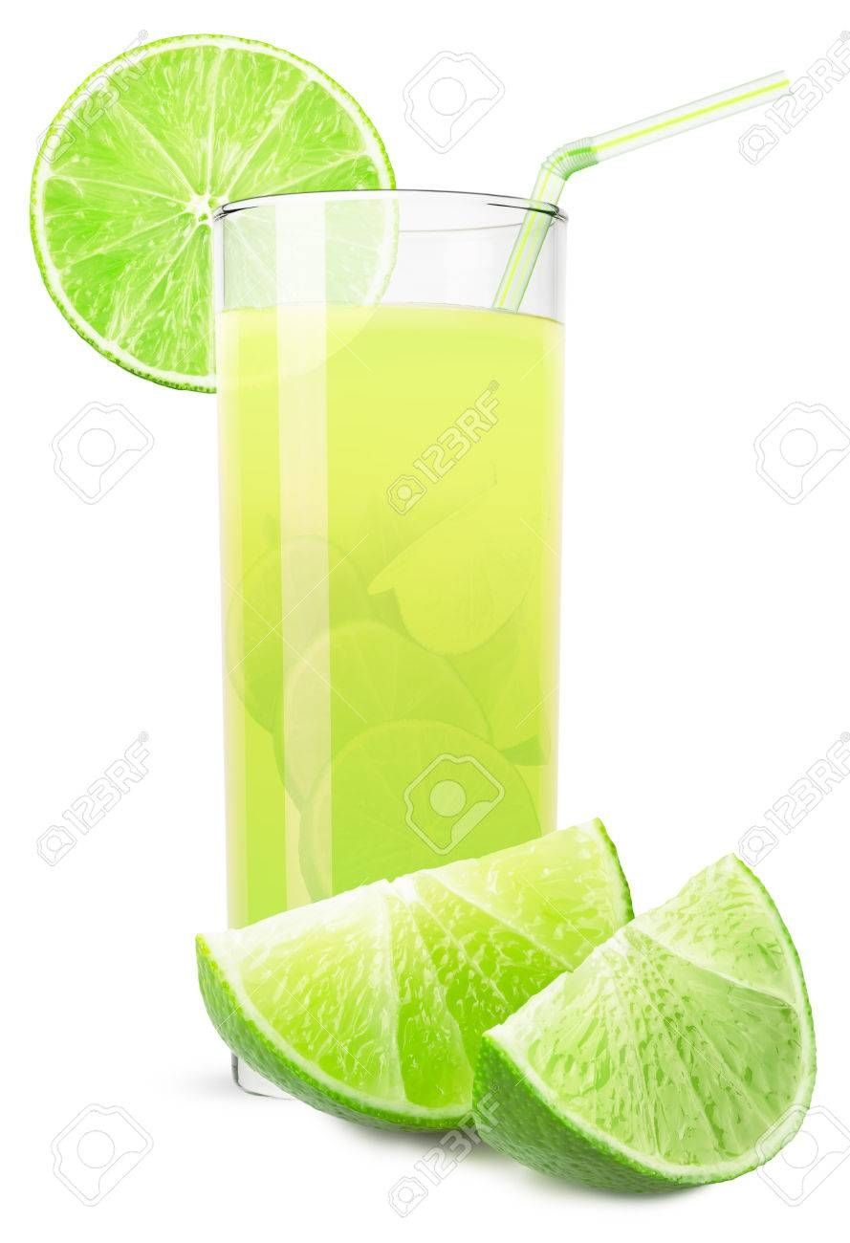

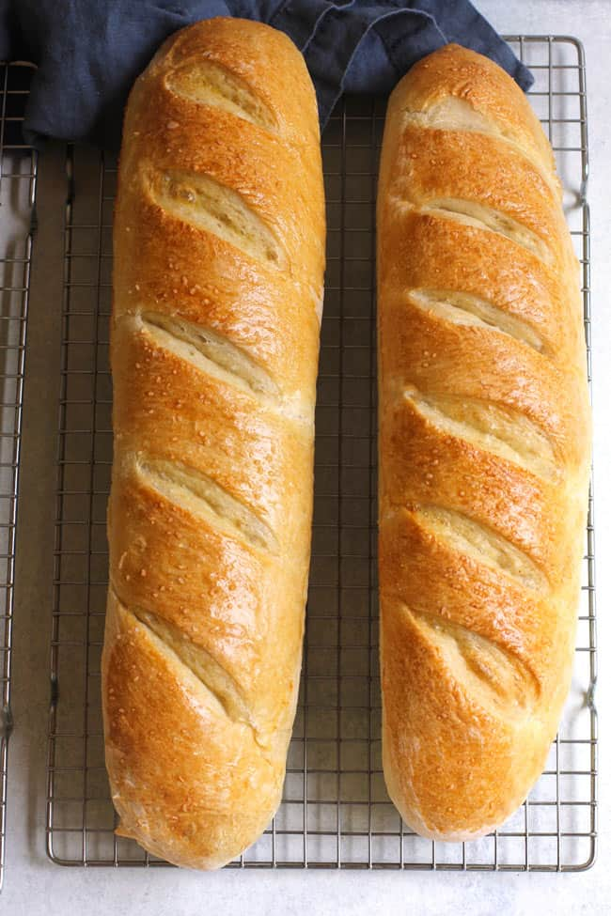

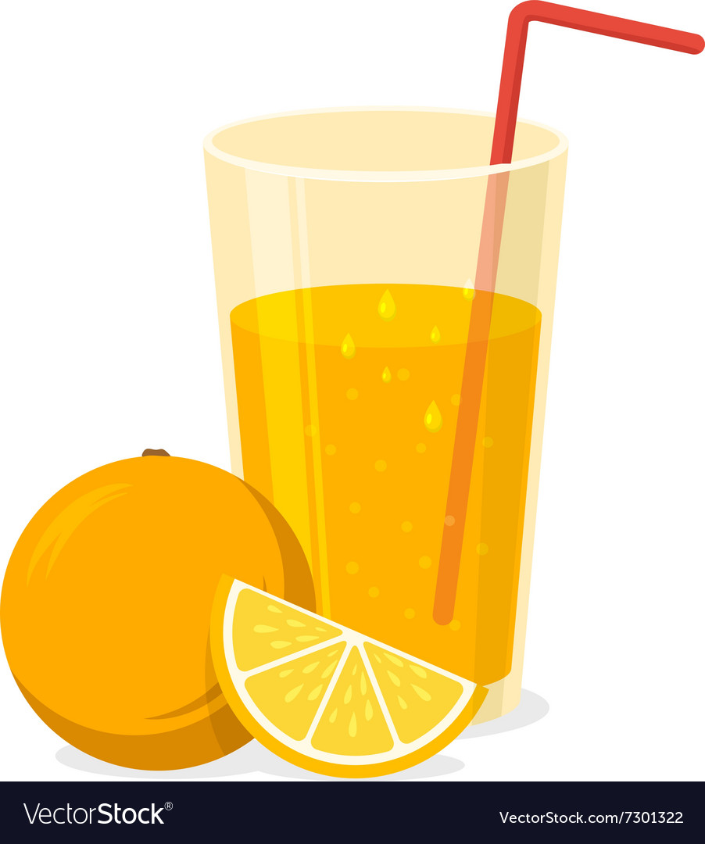

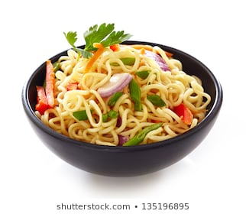

………………………… ………………………. ………………. ………………

**II. Choose the best answer.**

1. How about a _______?

A. meat                      B. cheese C. sandwich                  D. sugar

2. I don't want _______ meat.

A. a             B. some C. an                  D. any

3. They have _______ apple juice.

A. apple               B. some C. an                D. any

4. I like beef very much, but my brothers ________ .

A. don't                B. don't like C. aren't             D. aren't like

5. - _______ does Alice want?- She wants some ice-cream.

A. Who               B. What C. How              D. Why

6. - ______ does she want for dinner?- Rice and chicken.

A. Where          B. What C. Who             D. When

7. A ______ doesn't eat meat.

A. doctor              B. cook C. teacher              D. vegetarian

8. It's a good idea to drink_______ juice between meals.

A. some              B. these C. an                D. any

9. Which word is the odd one out?

A. mango             B. banana C. cabbage          D. grape

10. - What's the matter?- I'm very hungry. I want some _______ .

A. knives              B. iced tea C. lemonade            D. sandwiches

11. - Which are your brother's favorite dishes?- _______

A. No, thanks.      B. I'm thirsty. C. Cartoons and picture books. D. Chicken noodles and apple pies.

12. There aren't _______ oranges.

A. one            B. some C. an             D. any

13. - _______ is there to eat?- There're some apples.

A. Who                B. Where C. When             D. What

14. Which word has two syllables?

A. potato                B. favorite C. orange               D. banana

15. Which word is the odd one out?

A. milk                    B. coffee C. bread               D. tea

16. - __________ do you feel?- I feel very hungry.

A. Who                B. Why C. Which                     D. How

17. Match the adjective thin with its opposite.

A. good                  B. big C. thick                  D. heavy

18. We're very _______ now. We don't want any more food or drink.

A. cold                 B. hot C. full                        D. hungry

19. I would like ________ orange.

A. a                        B. an apple C. much                     D. any

20. Blackberries are his favorite ________ .

A. drink          B. vegetable C. meat                  D. fruit

21. - What are those?- ________ are beans.

A. They                B. There C. Them               D. Their

22. We want five ________ .

A. milk              B. bread C. melons            D. cheese

23. - ________ does she feel?- She feels happy.

A. When            B. How C. Who              D. Why

24. Are there ________ strawberries?

A. any            B. much C. a                D. an

25. I'm hungry. I want some ________ .

A. books             B. cakes C. water               D. pencils

26. - I feel very ________ .- You should put on more warm clothes.

A. hot                  B. thirsty C. hungry                D. cold

27. Would you like ________ glass of beer?

A. a                 B. some C. any            D. an

28. Bobby is drinking _______ .

A. cheese         B. bread C. tea               D. strawberries

29. There're ______ in the fridge.

A. chicken          B. milk C. ice-cream                    D. oranges

30. Lemonade is my favorite________ .

A. drink         B. fruit C. meat         D. vegetable

**III. Match:**

A B

1/ What’s for lunch? A. I’m cold.

2/ What’s your favourite drink? B. No, I’m not. I’m doing my homework.

3/ Are you watching TV? C. She feels very hot and tired.

4/ Is there anything to eat? D. I walk to school.

5/ What do you want? E. My favourite drink is iced-tea.

6/ How does Mai feel? F. I want some iced-tea.

7/ What’s the matter? G. There ia rice and vegetables.

8/ How do you travel to school? H. Yes, there are some oranges

**IV. Fill in each space with” a/ an or some/ any “:**

1.There isn’t ……………milk in the jar .

2. No, there aren’t ………….. noodles.

3. I have ………….. orange.

4. Do you have …………. meat?

5. I’m hungry. I’d like ……………chicken and rice.

6. I want ……………apple.

7. I’d like …………… milk .

8. Miss Lan wants ………………. beans .

9. That is …………onion.

10. Thuy has …………….. bike .

**V. Change into negative and interrogative forms**

1.Thu has some bread . ………………………………………………………….

………………………………………………………….

2. Lan & Vy have some milk . ………………………………………….…….….

………………………………………………………….

3. She wants some meat . ……………………………………………….. ………….

…………………………………………………………

4. There are some bananas. ………………………………………….……. ……….

………………………………………………………….

5. There is some rice . ………………………………………….…….. ….………

………………………………………………………….

**The end**